A line chart to showcase the regional distribution of total sales.

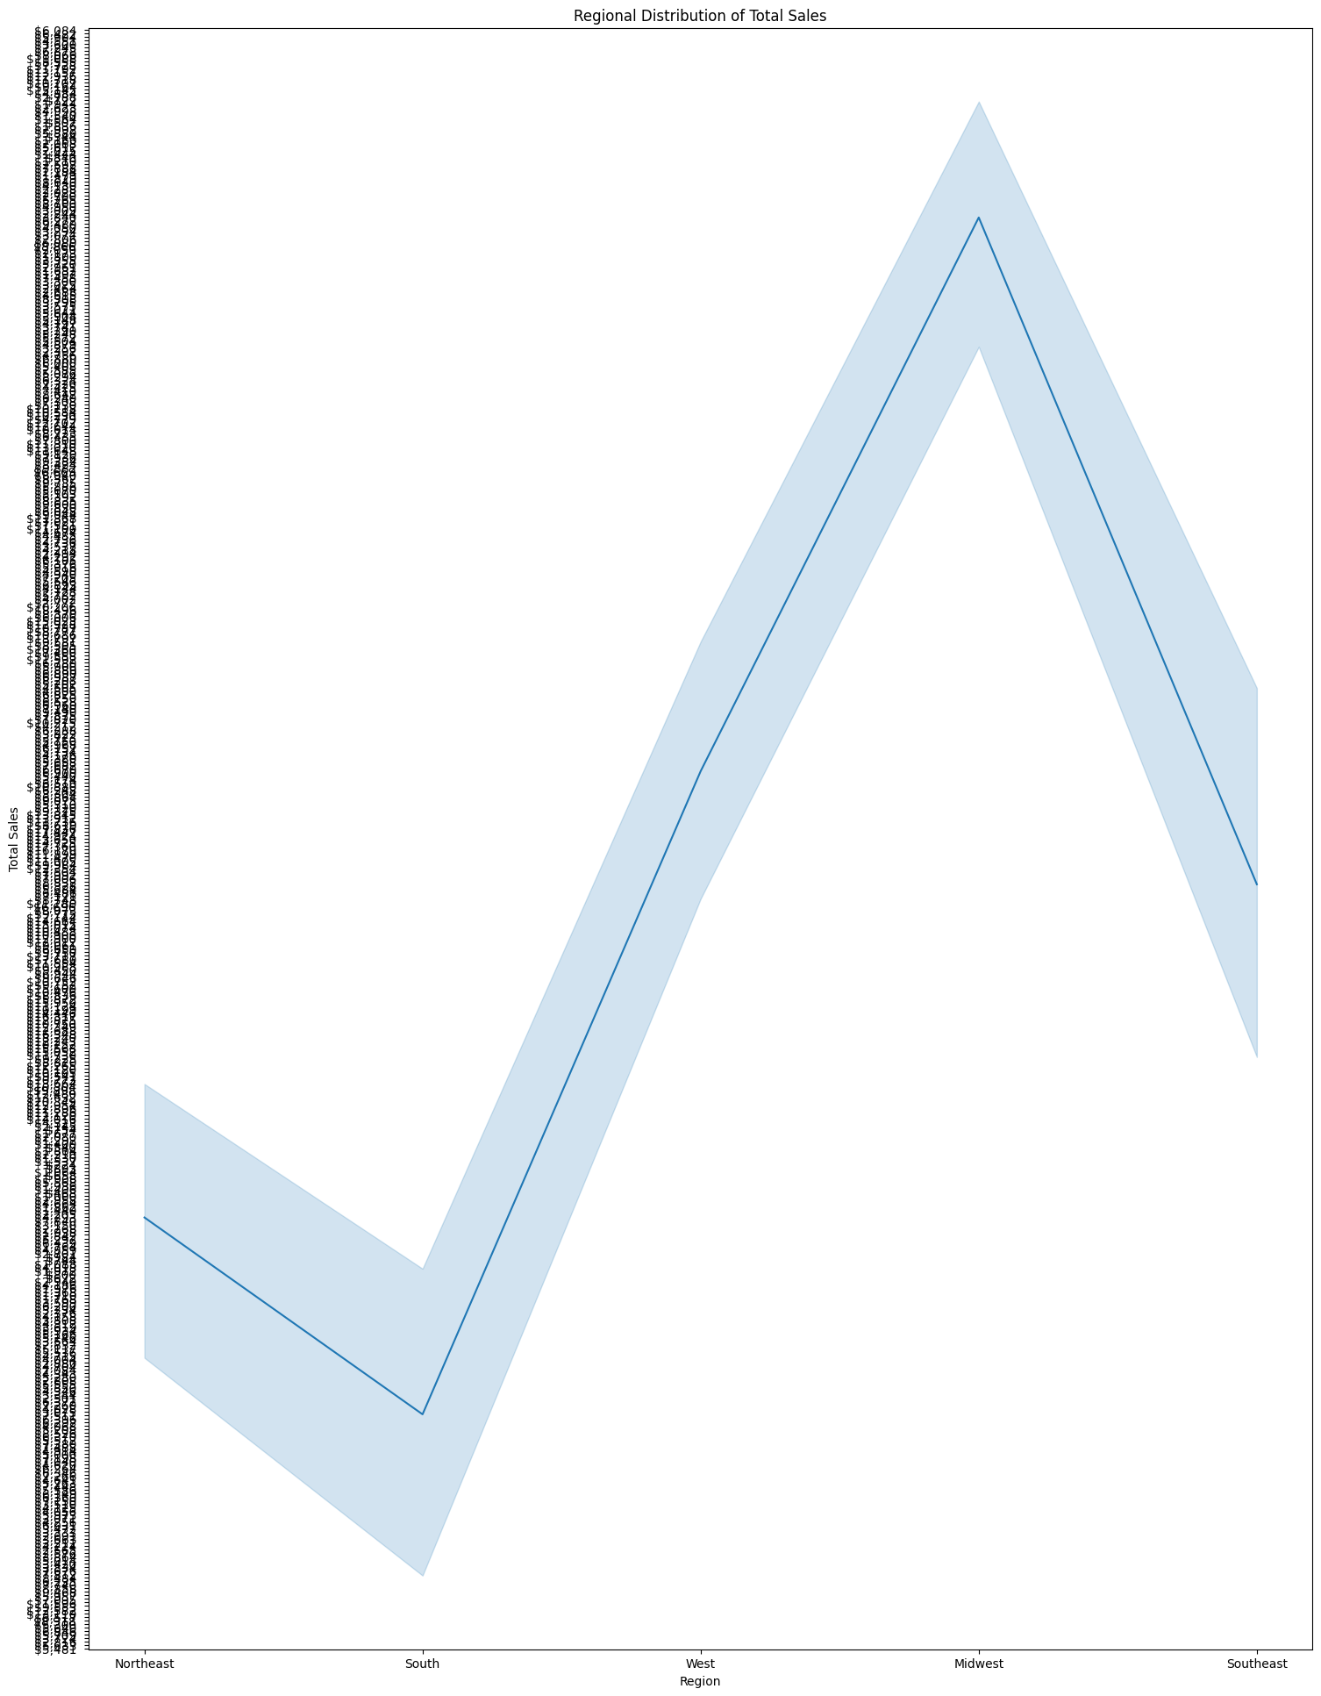

 A bar chart to visualize the quantity of each product sold.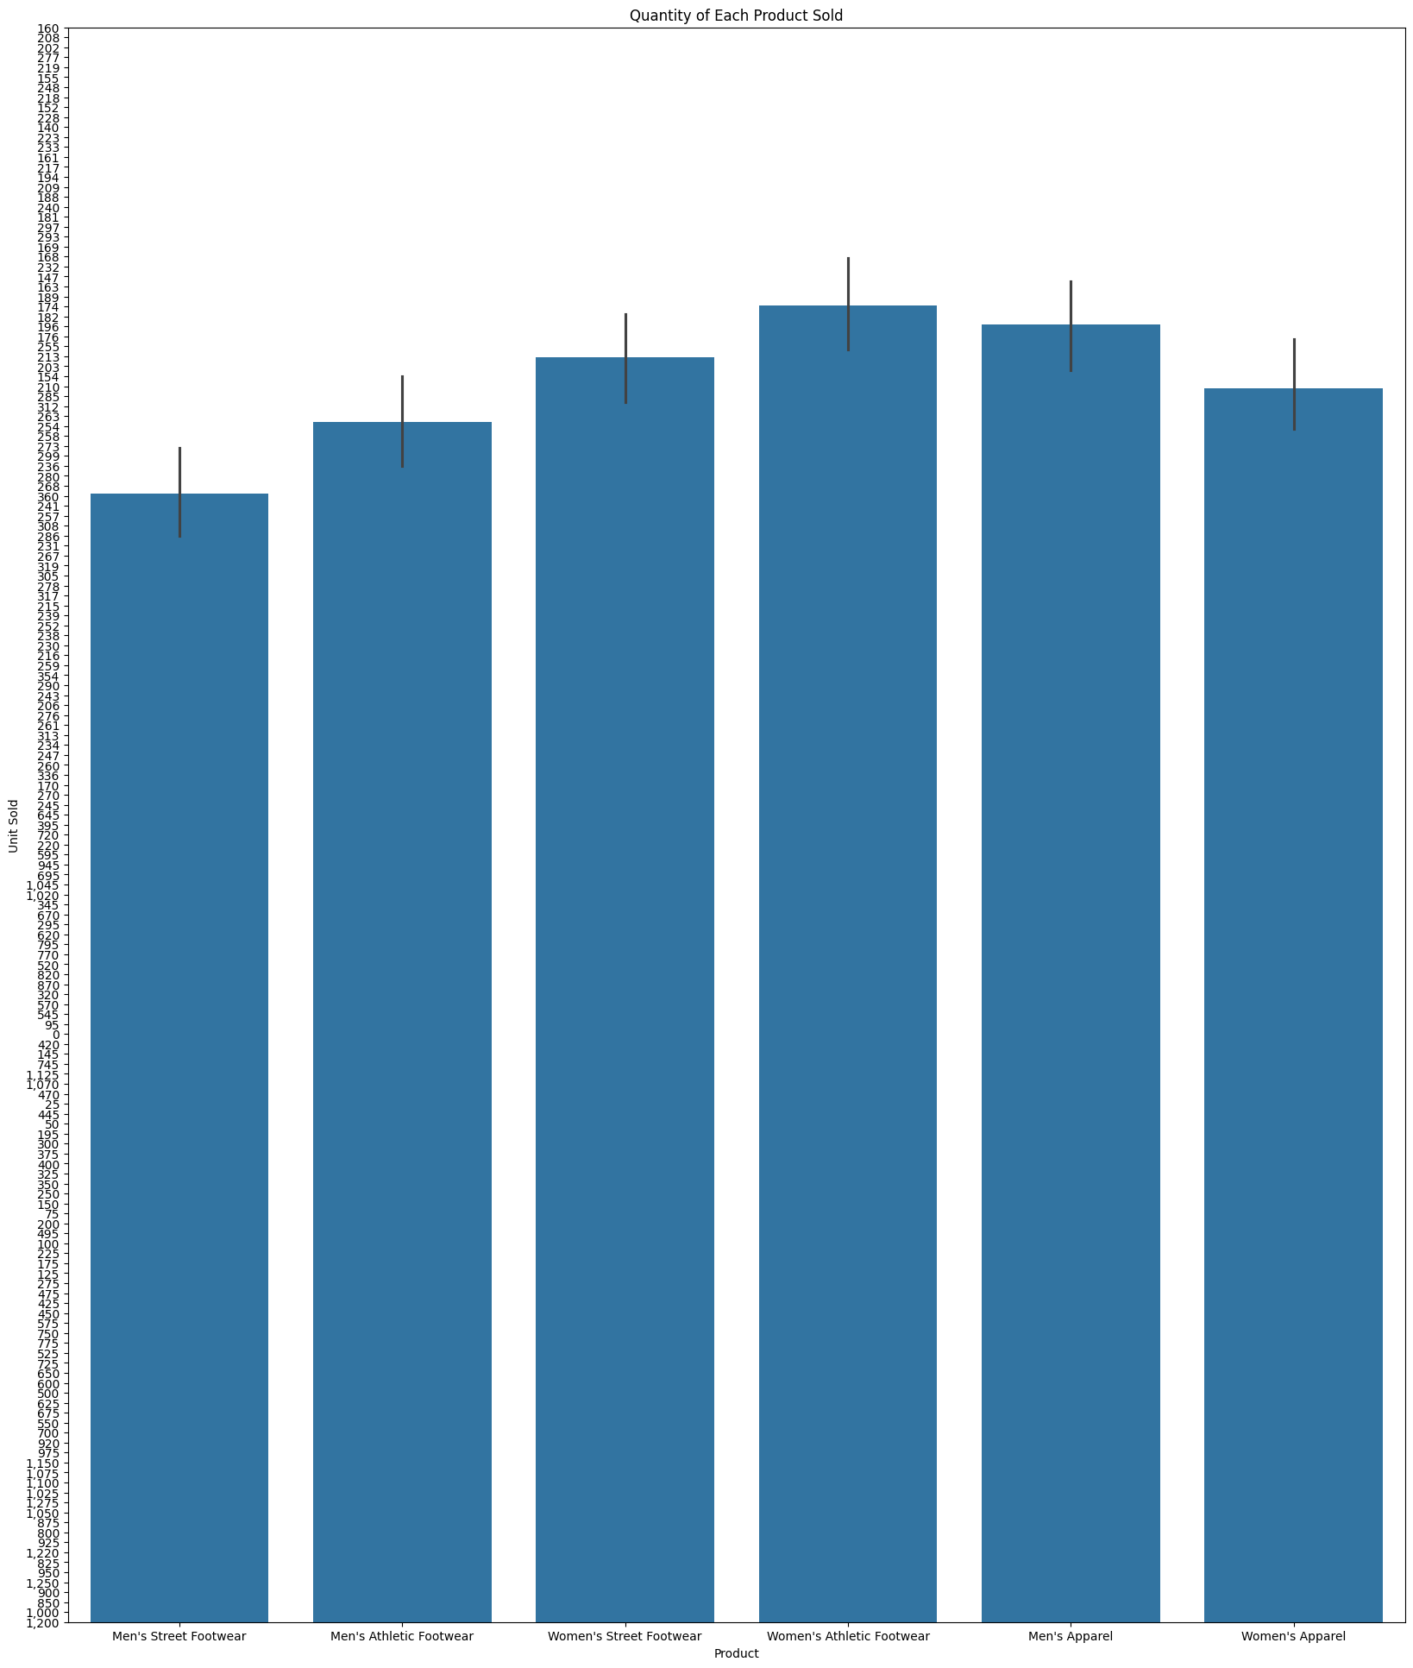

A scatter plot to explore the price per unit and the operating profit relation.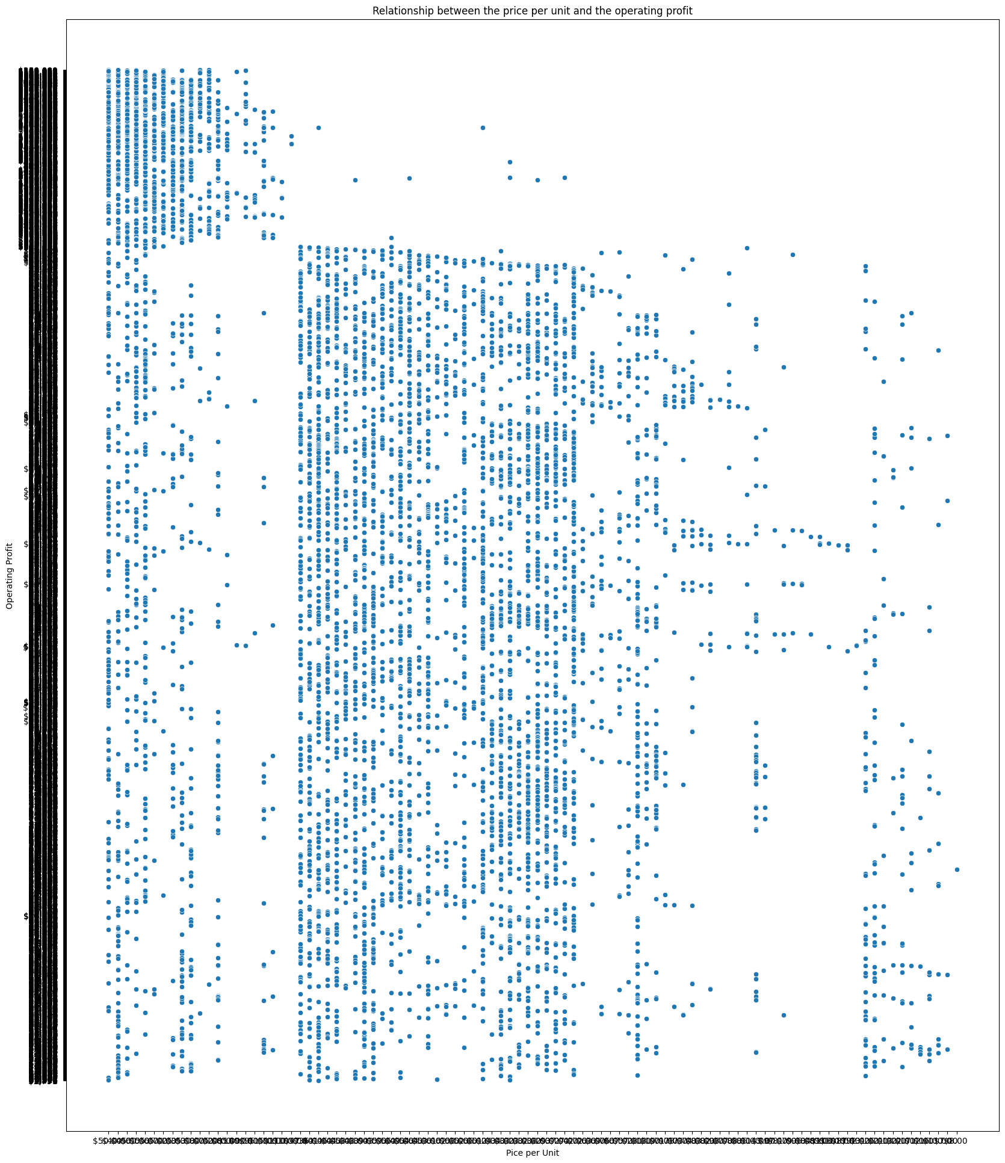

Comparison of the distribution of operating margins for different sales methods

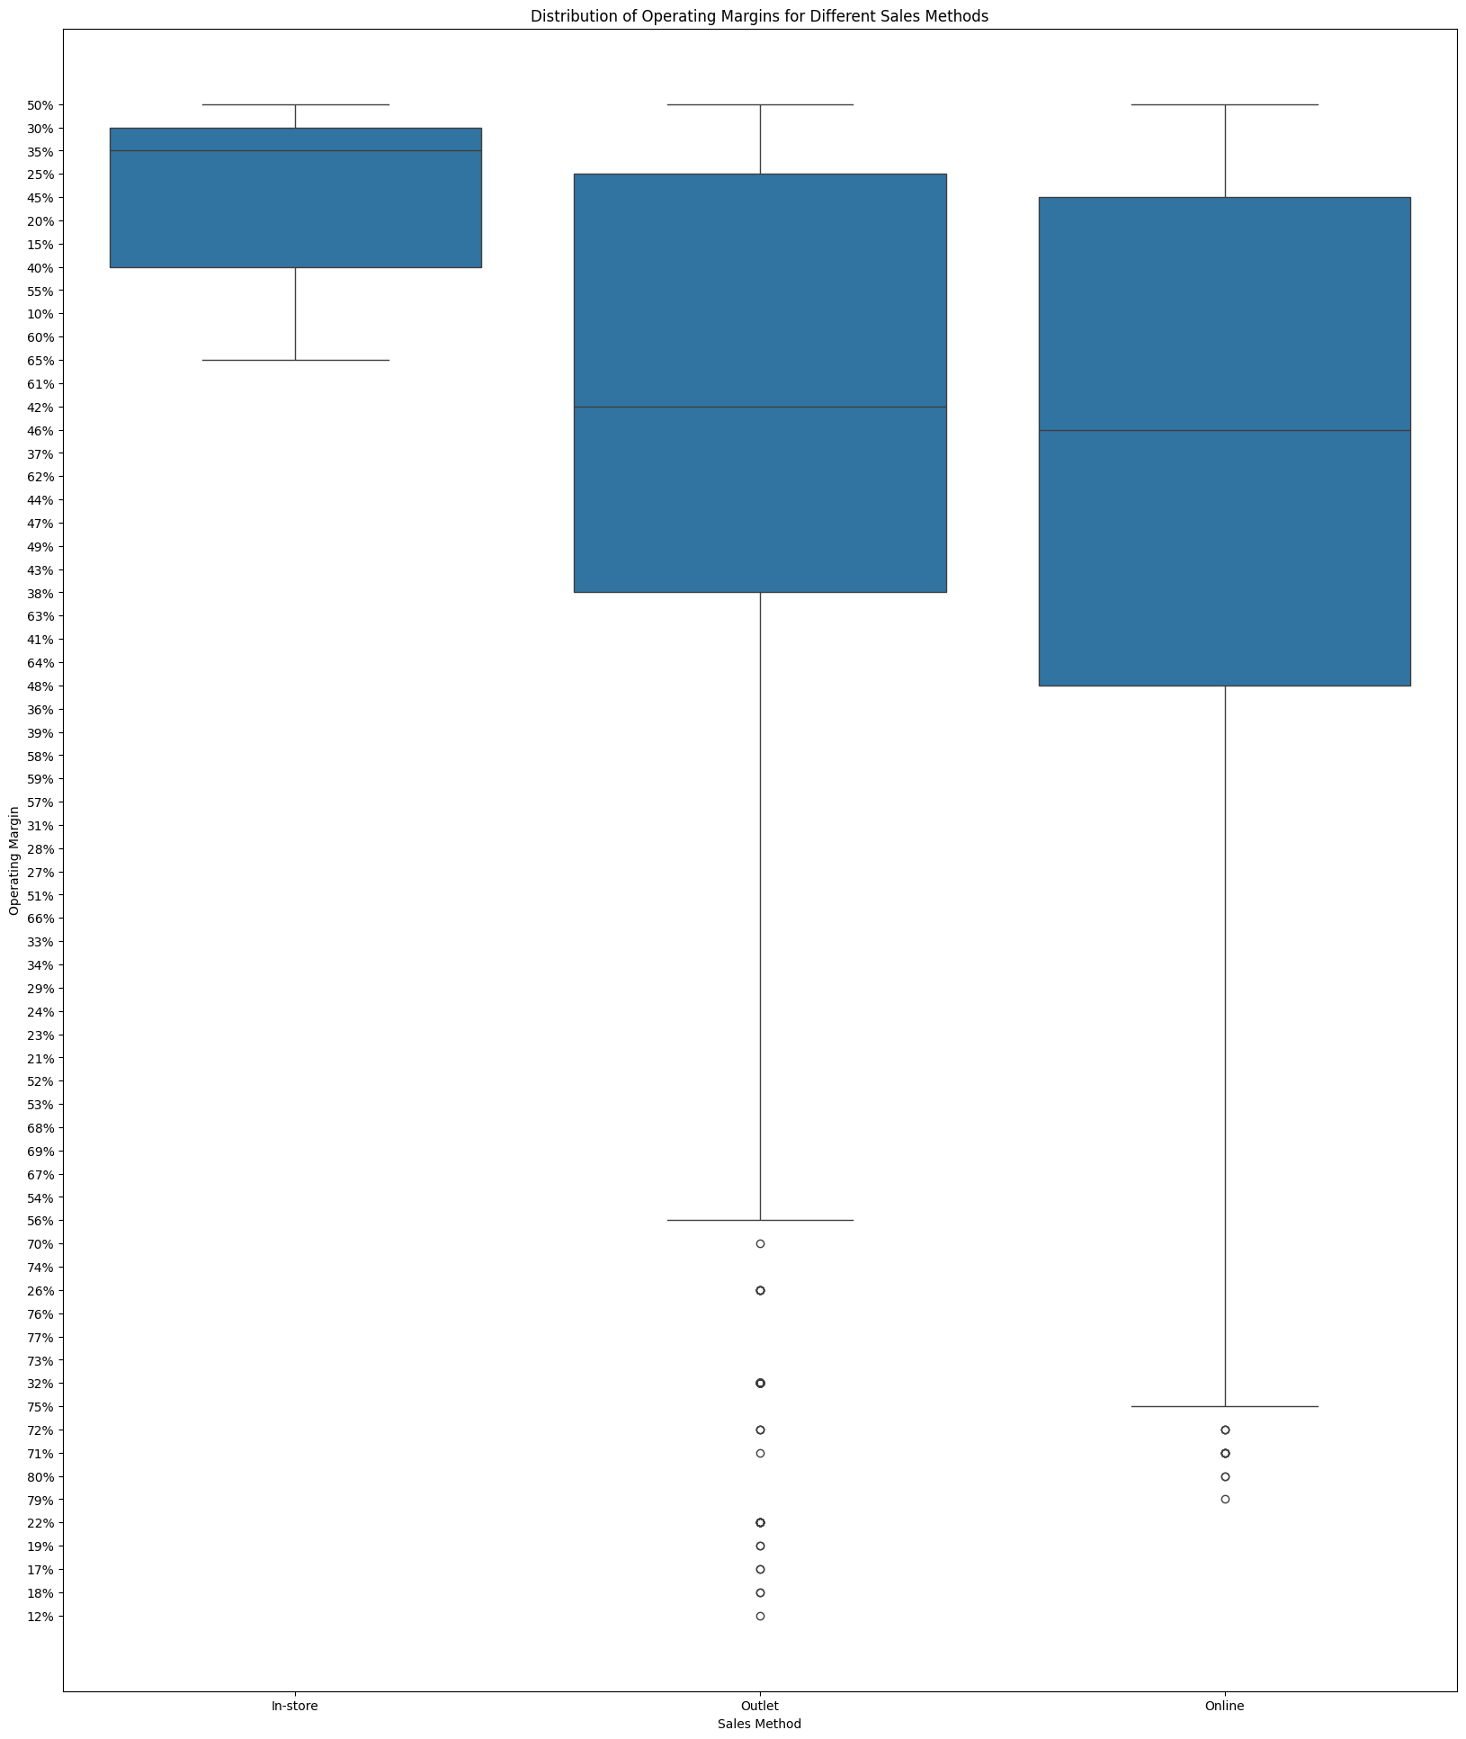

Insight: Online sales method is more effective compared to the rest of the sales methods.